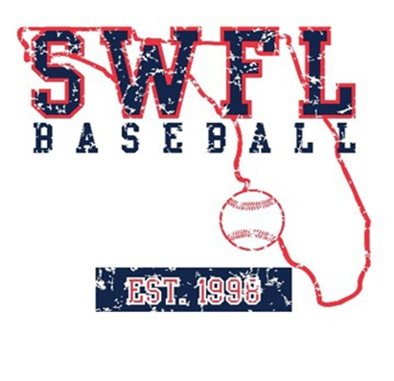
SWFL 2025 Nation, Summer 2024 schedule

June
1-2 SWFL Invitational Fort Myers, FL

7-10 Prospect Select Palm Beach World Series West Palm Beach, FL

13-16 PBR East Cup Bradenton, FL

22-29 PG WWBA Atlanta, GA

July

5-8 PG Florida World Series West Palm Beach, FL

13-18 PG BCS Fort Myers, FL

Coaches:
Marc Trudel
Len Brutcher
Andy Dolson

