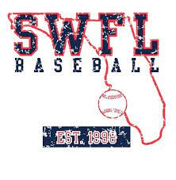
SWFL 2027 Nation
Brody Baxmann
Anthony Cabrera
Riley Hooker
Joey Karth
Ryder Lutz
Harry Martin
Micheal Magas
Brady Miller
Ashby Piatt
Jaxson Salazar
Boston Selig
Braylon Sheffield
Teegan Turner
Trillyon Venz
Logan Weber
Noah Kiefer

