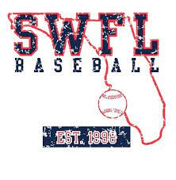
SWFL 2026 Nation
Gavin Cramer
Thomas Cox
Thomas Eaton
Ethan Fraginals
Gabe Garcia
Romero Gist
Dominic Giglio
Logan Hawkins
Aaron Hurley
Preston Nielson
Jayden Salazar
Austin Schoolcraft
Chase Skarbek
Nick Tobia

