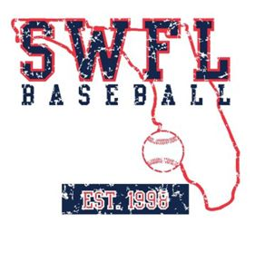

SWFL 2025 – Rockies Scout Fall Schedule

September

7-8 SWFL Invitational Fort Myers, FL
13-15 PG Florida Qualifier Sanford, FL
21 Florida Southwestern State Fort Myers, FL
25 State College of Florida Bradenton, FL
28 Santa Fe State Gainesville, FL

October

5 Seminole State College Sanford, FL

