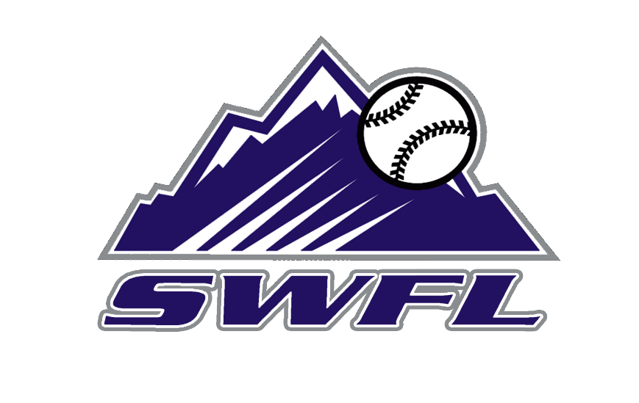
2027 SWFL Rockies Scout team schedule

May Event Location
17 SWFL Baseball Bash and BBQ Island Coast HS
23-26 PG Memorial Day Classic Fort Myers, FL
30-31 PG BCS Qualifier Fort Myers, FL

June
1-2 PG BCS Qualifier Fort Myers, FL
6-9 PG Florida Select Fort Myers, FL
14 Ostinger’s Baseball (DH) Fort Myers, FL
24-28 PG BCS Fort Myers, FL

July
6-13 WWBA World Championships Atlanta, GA
17-21 PG 16U World Series Sanford, FL

Coaches:
Derrik Lutz
Mark Sheffield
Adam Piatt

