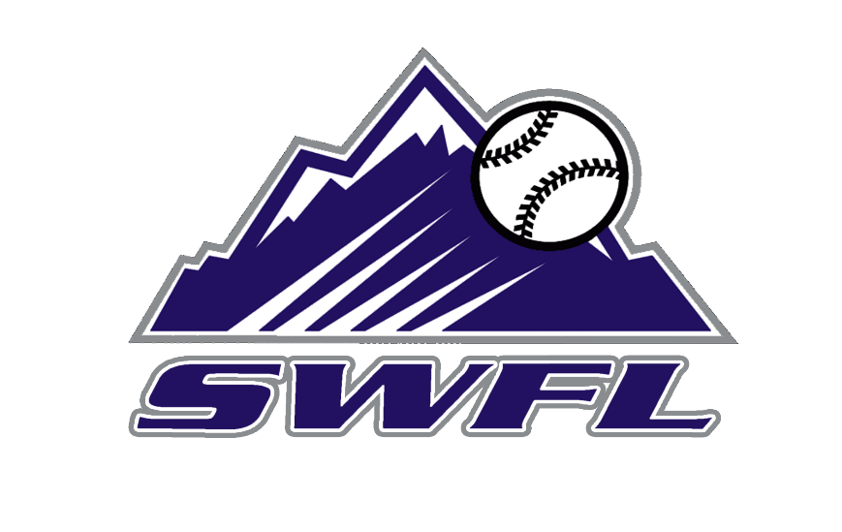
2026 SWFL Rockies Scout team schedule

May Event Location
17 SWFL Baseball Bash and BBQ Island Coast HS
30-31 PG BCS Qualifier Fort Myers, FL

June
1-2 PG BCS Qualifier Fort Myers, FL
6-11 Palm Beach Classic-Prospect Select West Palm Beach, FL
14 Pasco Hernando State Camp New Port Richey, FL
25 PG WWBA World Championships Atlanta, GA

July
1-2 PG WWBA World Championships Atlanta, GA
12-16 PG 17U Elite World Championships Hoover, AL
24-28 PG 17U PG BCS Fort Myers, FL

Coaches:
Eric Kindell
Brandon Bednar

