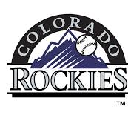

**2026 SWFL ROCKIES SCOUT TEAM**

|  |  |  |
| --- | --- | --- |
| **DATE** | **EVENT** | **LOCATION** |
| **SEP 7-8** | **SWFL INVITATIONAL** | **FT MYERS** |
| **SEP 14-15** | **FAU TEAM CAMP** | **BOCA RATON** |
| **SEP 21-22** | **FGCU TEAM CAMP** | **FT MYERS** |
| **SEP 28-29** | **JACKSONVILLE TEAM CAMP** | **JACKSONVILLE** |
| **OCT 3-6** | **UNDERCLASS CHAMPIONSHIP** | **FT MYERS** |
| **OCT 20** | **UCF TEAM CAMP** | **ORLANDO** |