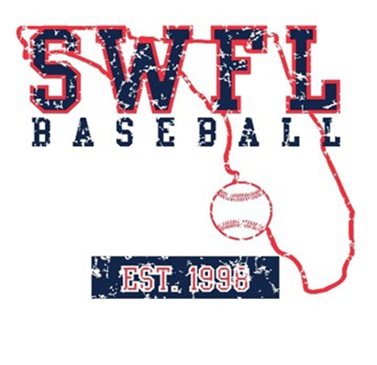
SWFL Baseball Upperclass summer schedule

June

1-2 SWFL Invitational Fort Myers, FL

7-10 PG Florida Select Fort Myers, FL

14-17 PG City of Palms Classic Fort Myers, FL

20-23 PBR Florida Open Bradenton, FL

28 PG Freedom Classic Fort Myers, FL

July

1 PG Freedom Classic Fort Myers, FL

13-18 PG BCS Fort Myers, FL

Coaches:
Chase Chatman
TBD

