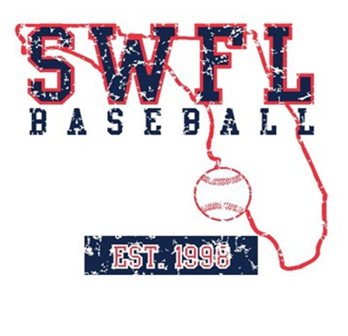
SWFL Baseball 2024 16U summer schedule

June
1-2 SWFL Invitational Fort Myers, FL

7-10 Palm Beach World Series West Palm Beach, fl

17-20 PG Jupiter Invitational Jupiter, FL

27-30 PBR Summer Championships Bradenton, FL

July

6-13 PG WWBA Atlanta, GA

20-25 PG BCS Fort Myers, FL

Coaches:
Clint Montgomery
Paul Greenleaf

