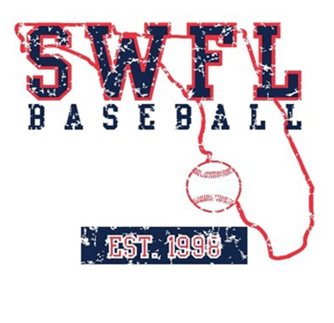
SWFL Baseball 2024 15U summer schedule

May

24-27 PG Memorial Day Fort Myers, FL

31 PG BCS Qualifier Fort Myers, FL

June

2-3 PG BCS Qualifier Fort Myers, FL

14-17 PG City of Palms Fort Myers, FL

July

6-11 PG BCS Ft. Myers, FL

15-22 PG WWBA Atlanta, GA

23-26 IMG International Bradenton, FL

Coaches:
Derrik Lutz
Mark Sheffield

